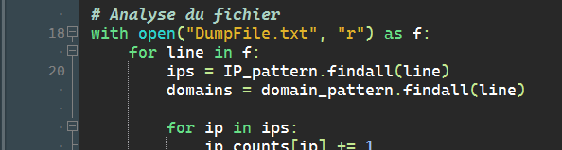

Here you enter the name of the file to process.

Then you compile the program, you install the libraries necessary for the program to function in the event of an error, then you open the file “Rapport_Analyse_Trafic.html” here you will find the report detailing what the analyzed file contains, and the potential activities suspicious.

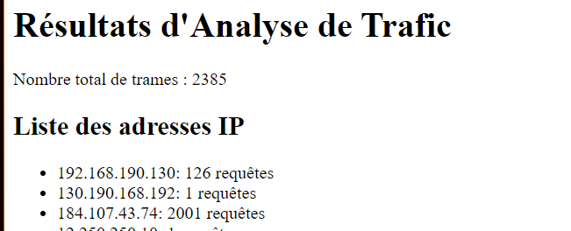
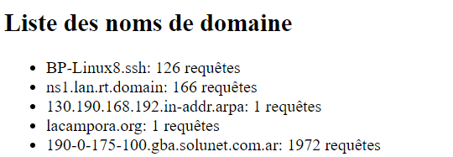

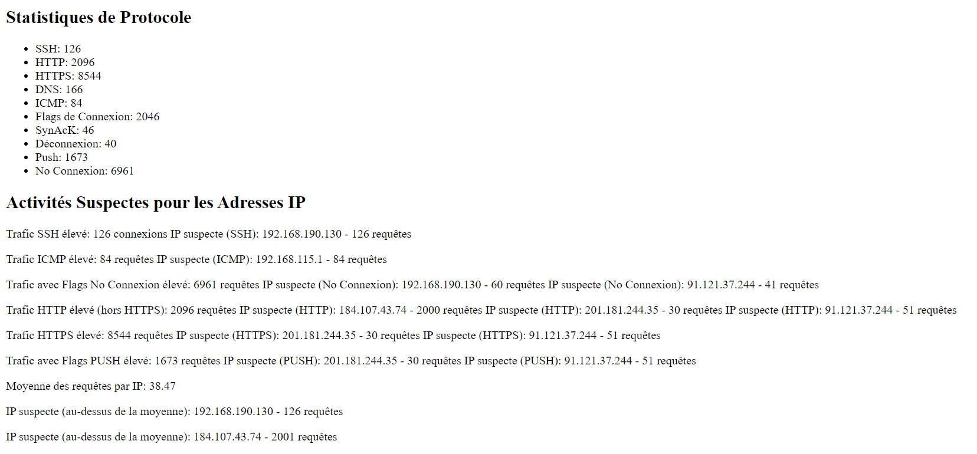

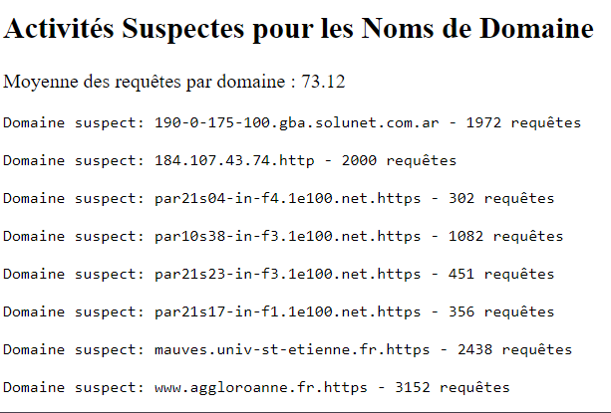

After that, you can open the “rapport.csv” file and open it in Excel.

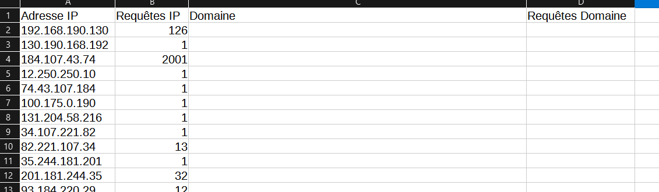
So here we have the IP addresses, the number of IP requests, the domains, and the number of domain requests.

With this information if you select all the information you go to insert → graph, then you will be able to create a graph with the IP addresses and domain.
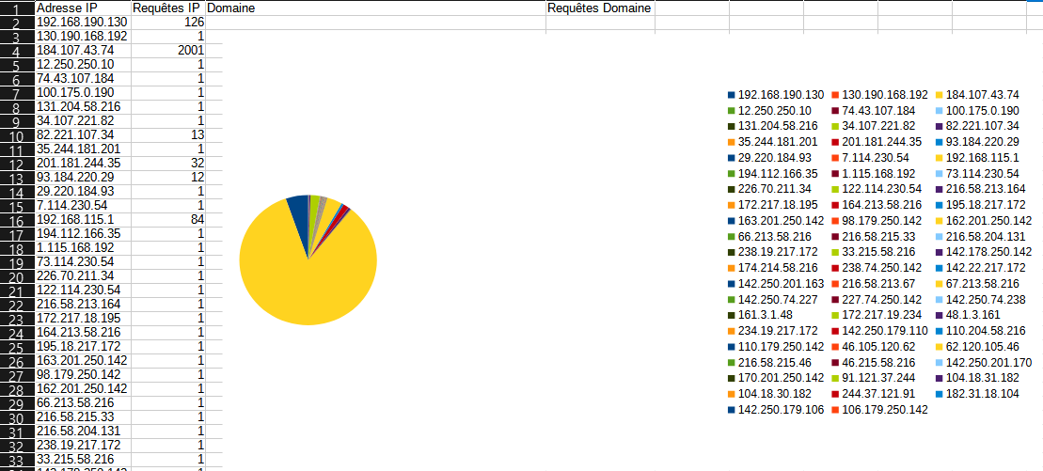

Here for example you have a diagram for IPs
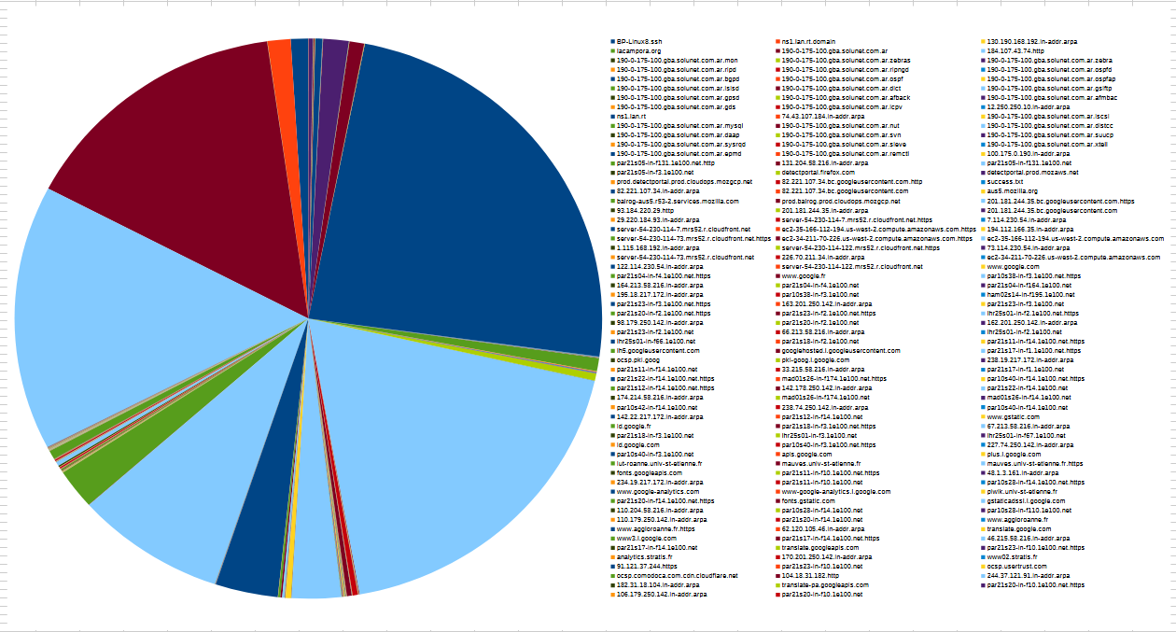
And here you have the graph for the domains.

